Advanced Airway Management
A Self-Directed Learning Module
Technical Skills Program
Queen’s University
Department of Emergency Medicine
Introduction
The goal of this module is for students to acquire the knowledge and skills necessary to manage an apneic patient. There are a multitude of skills which you will need to acquire, but at all times the skills must be learned in the context of avoiding hypoxia in your patient. This means always establishing and maintaining an open airway, and providing adequate ventilation of the chest.
Equipment tray
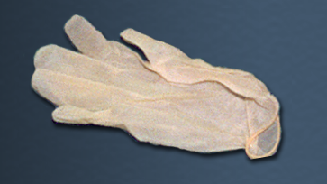 | Gloves:  The rescuer should at all times avoid direct contact with the blood and other body fluids of the patient. If available, gloves should be worn during all airway management procedures.
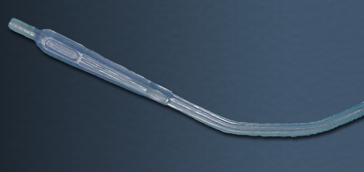 | Suction:  In most resuscitation situations, the patient will either vomit, or at the very least, will have an excess of secretions in their oropharynx. If available, a suction catheter should be included as part of your basic airway equipment.
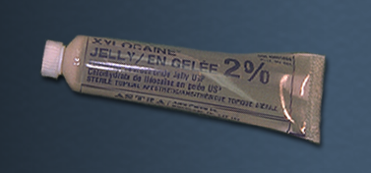 | Lubrication:  The tip of the endotracheal tube should be lubricated prior to insertion. Xylocaine® jelly is a good lubricant because it reduces irritation due to its local anesthetic effect.
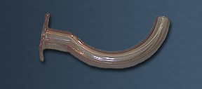 | Oropharyngeal airway:  In basic airway management, the oropharyngeal airway is used to provide a patent airway to facilitate chest ventilation. In advanced airway management, it can be inserted following endotracheal intubation to act as a bite-block to protect the endotracheal tube.
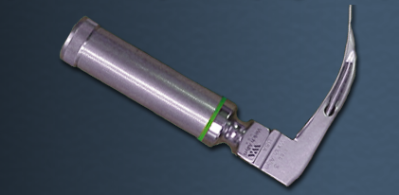 | Laryngoscope:  The laryngoscope handle and blade are used to elevate the tongue and mandible to allow visualization of the cords. The blade can be straight (Miller) or curved (Macintosh). Miller blades are usually reserved for pediatric patients while most physicians use a Macintosh blade for adults. An average sized adult patient would require a #3 Macintosh blade. The blade must be long enough to reach the vallecula (the space between the base of the tongues and the epiglottis).
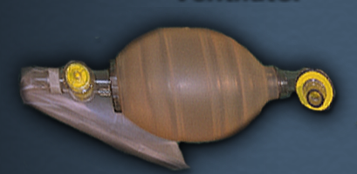 | Bag-valve ventilator:  The bag-valve ventilator is a device designed to ventilate the chest. By attaching an oxygen supply, it can be used to ventilate the chest with a high concentration of oxygen. The bag-valve ventilator can be used with a mask, as in basic airway management, or it can be attached to an endotracheal tube as part of advanced airway management.
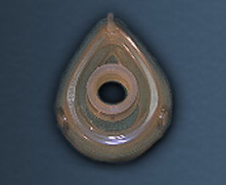 | Mask:  Masks are used to provide a tight seal between the patient's face and the bag-valve ventilator. Masks come in various of sizes. The correct size of mask for a particular patient should provide a tight seal around the mouth and nose. The mask will be needed to ventilate the patient prior to endotracheal intubation.
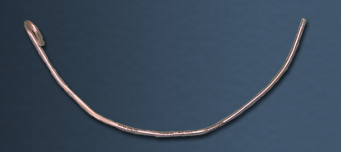 | Stylet:  A stylet can be inserted inside an endotracheal tube to make it more rigid, or to change the shape of the tube. For example, the tip of the endotracheal tube can be bent slightly to facilitate passage through the cords. It is recommended that the stylet be used in all emergency intubations. In this way, if the shape of the tube needs to be modified, the stylet is already in place. The stylet should be lubricated prior to insertion into the endotracheal tube, so that it is easy to remove.
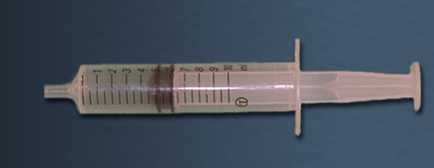 | Syringe:  Endotracheal tubes used in adults have an inflatable cuff near the tip. The cuff, once inflated, is intended to seal the airway from aspiration of oropharyngeal contents, and to prevent air leaks during positive pressure ventilation. A 10 cc syringe should be included on the aspiration tray to inflate the cuff of the tube with 5-10 cc's of air.
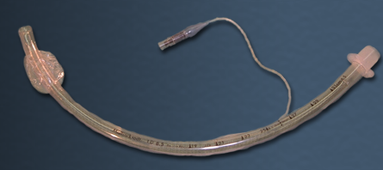 | Endotracheal tube:  A properly positioned endotracheal (ET) tube will protect the airway from aspiration and greatly facilitate bag-valve ventilation. An adapter at the proximal end allows attachment to a bag-valve ventilator or mechanical ventilator. The internal diameter of the cuff is printed on the side of the ET tube. A 7.5 mm ET tube would be used in an average-sized adult female, and an 8.0 mm ET tube in an average-sized male. The ET tube is also marked in cm to show how far the tube has been advanced into the trachea.
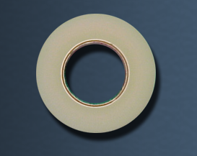 | Tape:  Once in place, the ET tube must be secured to avoid inadvertent extubation or migration of the tube down the airway. It is usually taped in place following confirmation of correct ET tube position.
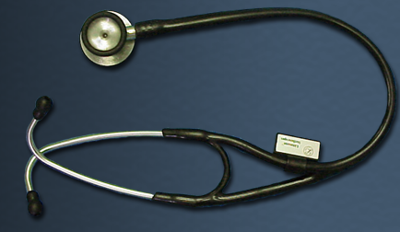 | Stethoscope:  The position of the ET tube is confirmed by listening over the lung fields and the epigastrium with a stethoscope. The worst possible outcome of an attempt at endotracheal intubation is unrecognized esophageal intubation. It is absolutely essential that a stethoscope be used to confirm tube positioning by listening over both lung fields and the epigastrium.
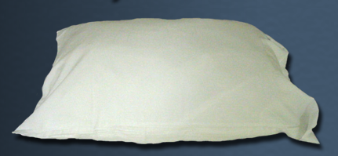 | Pillow  Correct positioning of the patient's head and neck (neck flexed with extension at the atlanto-occipital joint) will make it much easier to visualize the vocal cords during laryngoscopy. In fact, failed intubation can often be traced to incorrect head positioning prior to laryngoscopy. A pillow or other pad is placed underneath the patient's occiput in order to flex the lower part of the C-spine. The rescuer then extends the head at the atlanto-occipital joint.
Step 1: Ventilate patient
Advanced airway management begins with an open airway and adequate chest ventilation using basic airway management techniques. At all times, it must be remembered that the most important determinant of patient outcome is adequate chest ventilation. If difficulties are encountered during attempts at endotracheal intubation, the rescuer should stop and resume basic techniques to ensure chest ventilation.
Note correct technique:
Prior to attempting endotracheal intubation, the rescuer should ventilate the chest to optimize tissue oxygenation. This will provide a reserve of oxygen in the lungs and thus allow a period of apnea during intubation.
Step 2: Position head and neck
One of the most common reasons for failed endotracheal intubation is improper patient positioning. The correct position is with the lower part of the cervical spine flexed, and the atlanto-occipital joint extended - the so-called "sniffing position". This position aligns the axes of the mouth, pharynx and trachea, and will give the best visualization of the cords during laryngoscopy. Failure to correctly position the patient will ensure a "difficult" intubation.
Note correct technique:
- The lower part of the cervical spine is flexed by placing a pillow or other suitable pad under the patient's occiput.
- The atlanto-occipital joint is extended by tilting the head back.
Step 3: Ventilate patient
Following positioning of the head and neck, we recommend that you resume chest ventilation prior to intubation. However, some experts may choose to omit this step and proceed directly to laryngoscopy.
Step 4: Remove airway
If an OP and NP airway have been used, they should be removed at this point, prior to laryngoscopy.
Note correct technique:
Gently remove the airway, respecting the teeth and lips.
Step 5: Position laryngoscope
The laryngoscope is used to move the tongue out of the way, and to elevate the mandible. The curved blade has a groove on its left side to "scoop" the tongue as the rescuer sweeps in a right right-to-left direction.
Note correct technique:
- The tip of the blade is inserted into the right side of the mouth, and advanced towards the right tonsillar pillar.
- The blade is moved to the midline, sweeping the tongue left, once the right tonillar fossa is visualized.
- The blade is then advanced into the vallecula, between the base of the tongue and the epiglottis.
Can't see much? Try using suction...
In resuscitations, it is common for the patient to either vomit or have an excess of oropharyngeal secretions. If available, suction should be included in your advanced airway management equipment.
Step 6: Elevate mandible
Correct technique:
With the tongues swept out of the way, and the tip of the laryngoscope blade in the vallecula, you are now ready to elevate the mandible. This should provide an unobstructed view of the vocal cords, and room to pass the ET tube into the trachea.
Note correct technique:
The mandible is elevated by moving the handle in the direction it is pointing, at approximately a 45 degree angle. The handle should not be used as a lever, as this can result in dental injury.
Incorrect technique:
It is common for novices to pull back on the handle of the laryngoscope to facilitate visualization of the cords. This can result in significant injury to the teeth or lips.
DO NOT USE THE HANDLE AS A LEVER! Note that by pulling back on the handle, the rescuer in this video clip is coming in contact with the patient's teeth.
Step 7: Visualize cords
With elevation of the mandible, the vocal cords should come into view. It is essential that you actually visualize the cords prior to passing the tube so as to minimize the risk of esophageal intubation.
Note correct technique:
As you watch the video clip, you should be able to identify the:
- laryngoscope blade
- tongue (being displaced to the left)
- epiglottis (at the tip of the blade, above cords)
- vocal cords
Step 8: Pass the tube
The rescuer should try to maintain visualization of the cords while the ET tube is being passed through the oropharynx. The cuff of the tube should be advanced just past the vocal cords. As an approximate landmark for adults, the 22 cm mark on the tube should be at the corner of the patient's mouth when the ET tube is correctly positioned in the trachea.
Note correct technique:
- Bring the ET tube in from the right side of the patient's head.
- Insert the ET tube in the right side of the oropharynx.
- Advance the ET tube towards the vocal cords, maintaining visualization of the cords.
- Watch the ET tube pass through the cords. The tube should be advanced so that the cuff is just past the cords.
Step 9: Remove laryngoscope and stylet
The laryngoscope and stylet are withdrawn.
Note correct technique:
- The laryngoscope is gently withdrawn with respect for the lips and teeth.
- To avoid inadvertent extubation, secure the ET tube with one hand, and withdraw the stylet with the other.
Step 10: Inflate cuff
The inflatable cuff on the ET tube functions to seal the airway against oropharyngeal contents and prevent air leaks during positive pressure ventilation. The exact volume of air will vary, but should be just enough to prevent air leaks around the tube. Note: prolonged over-inflation of the cuff can cause pressure necrosis of the tracheal mucosa.
Note correct technique:
While securing the ET tube with one hand, inflate the cuff with 5-10 cc's of air. The volume of air can be adjusted later when the airway is secured.
Step 11: Check placement
The worst possible outcome of attempted endotracheal intubation is unrecognized esophageal intubation. The tube placement is confirmed by listening for air entry over both lung fields and over the epigastrium. If air entry or a "gurgling" sound is heard over the epigastrium, or there is an absence of air entry over the lung fields, the rescuer should immediately remove the ET tube and resume bag-valve-ventilation. If air entry is only heard over the right lung field, the ET tube may have been advanced too far - into the right main stem bronchus. In this circumstance, the ET tube should be withdrawn so that the 22 cm mark on the tube is at the corner of the mouth.
Note correct technique:
- Attach bag-valve ventilator to ET tube.
- Don stethoscope prior to first ventilation.
- Listen over epigastrium with first ventilation.
- Listen over both lung fields with subsequent ventilations.
- Listen to trachea for air leaks.
Step 12: Ventilate patient
Resume ventilation with bag-valve ventilator attached to the ET tube.
Note correct technique:
Ventilate the patient at a rate of 10-12 breaths per minute. At this point, an oral airway can be inserted as a bite-block to protect the ET tube.
Step 13: Secure the tube
Finally, the ET tube is secured in place.
Note correct technique:
While maintaining a ventilatory rate of 10-12 breaths per minute, the rescuer secures the ET tube using a single loop of tape, as demonstrated in the video.
Credits
Congratulations!
You have now completed the Advanced Airway Management module.
Credits
- This web-based module was developed by Adam Szulewski based on content written by Dr. Bob McGraw for the Queen's University Department of Emergency Medicine Summer Seminar Series and Technical Skills Program.
- The module was created using exe : eLearning XHTML editor with support from Amy Allcock and the Queen's University School of Medicine MedTech Unit.
License
This module is licensed under the Creative Commons Attribution Non-Commercial No Derivatives license. The module may be redistributed and used provided that credit is given to the author and it is used for non-commercial purposes only. The contents of this presentation cannot be changed or used individually. For more information on the Creative Commons license model and the specific terms of this license, please visit creativecommons.ca.

